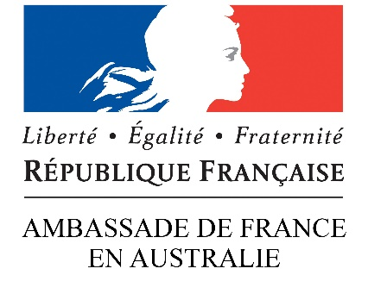
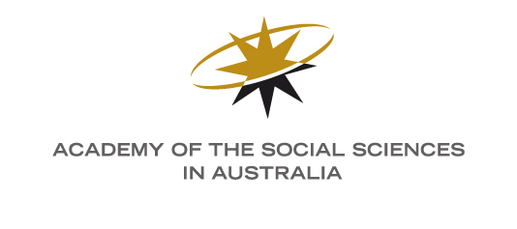

Australia-France Social Science Collaborative Research Program

APPLICATION FORM - 2020
Applicant Name:
Institution:
Contact Details:
Project Title:
Amount Requested:
Proposed Start Date:
Duration:

Project Summary
Outline the significance of the project, its structure, purpose, goals, and expected outcomes.
(max 300 words)
Alignment to Program
(Tick each box that applies to your project)
☐ Research activities on a topic of interest to both Australia and France, provided to eligible French and Australian researchers, especially early and mid-career researchers.
☐ Research activities relevant to Pacific Island Studies (including those in French overseas territories).
☐ Research activities with the capacity to support the development of strategic alliances between France and Australia.
Proposed Budget
Research Team - Collaborators
(List details of all researchers or collaborators on this project)

Agreement
By submitting your application, you acknowledge and agree to the following:
☐ Information on this form is collected to make recommendations to the French Ministry of Foreign Affairs and the Academy of the Social Sciences in Australia on the allocation of financial assistance under their respective budgets. The information collected may be passed to assessors for the purposes of obtaining a peer-review assessment of the application. It may also be passed to other funding bodies and other public organisations (inc. Universities and research bodies) judged appropriate by the funding organisations. In other instances, information on this form can be disclosed without your consent where authorised or required by law.
☐ While the Embassy of France and the Academy’s selection committee gives careful consideration to applications, it is not able to enter into discussion or correspondence regarding the reasons why an application is unsuccessful.
☐ Successful applicants, or their institution, will invoice the Academy for the awarded amount prior to the close of the financial year 2019-20.
☐ Successful applicants are required to submit a report of the research activities funded by the program and an acquittal of funds within two months following the completion of the funding activity.
Applicant Name:
Signature:

Applications should be submitted to dylan.clements@assa.edu.au no later than midnight 17 November 2019.
Application outcomes will be notified by 17 January 2020 for immediate provision of funding.

