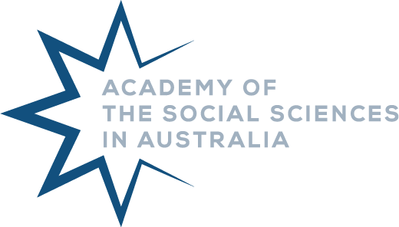
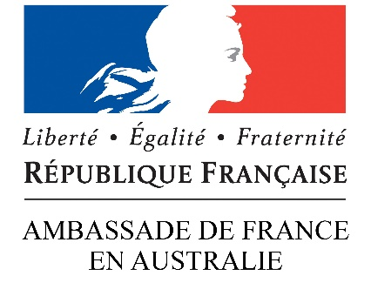

Australia-France Social Science Collaborative Research Program
2023 Application Form
- Applicant Details
Full Name:
Title, First Name, Surname
Discipline/s:
Institution:
Position Title:
Email:
Phone:
Applicant Address:
Institution Address:

- Project Details
Project Title

Start and End Date of Project
Funding is available to support activities within a two year (24 month) timeframe.
Start Date: |  | End Date:

Project Summary
Outline the significance of the project, its structure, purpose, goals, and expected outcomes (max 500 words).

Alignment to Program
Tick each box that applies to your project
☐ Research activities on a topic of interest to both Australia and France, provided to eligible French and Australian researchers, especially early and mid-career researchers.
☐ Research activities relevant to Pacific Island Studies (including those in French overseas territories).
☐ Research activities relevant to the Indo-Pacific region.
☐ Research activities with the capacity to support the development of strategic alliances between France and Australia.

Research Team - Collaborators
List details of all researchers or collaborators on this project

Early Career Researchers
Please indicate the name, year of PhD award, and any eligible career interruptions of any early-career researchers involved in the project.

- Finance
Total Grant Requested
The maximum grant available through this program is $5,000 AUD.

Proposed Budget

- Agreement
By submitting your application, you acknowledge and agree to the following:
☐ Information on this form is collected to make recommendations to the French Ministry of Foreign Affairs and the Academy of the Social Sciences in Australia on the allocation of financial assistance under their respective budgets. The information collected may be passed to assessors for the purposes of obtaining a peer-review assessment of the application. It may also be passed to other funding bodies and other public organisations (inc. Universities and research bodies) judged appropriate by the funding organisations. In other instances, information on this form can be disclosed without your consent where authorised or required by law.
☐ While the Embassy of France and the Academy’s selection committee gives careful consideration to applications, it is not able to enter into discussion or correspondence regarding the reasons why an application is unsuccessful.
☐ Successful applicants, or their institution, will invoice the Academy for the awarded amount prior to the close of the financial year 2022-23.
☐ Successful applicants are required to submit a report of the research activities funded by the program and an acquittal of funds within two months following the completion of the funding activity.

Applicant Name:
Signature:

☐ I wish to be added to the Academy’s monthly mailing list to receive communications about further grants, awards, activities and opportunities with the Academy.

Applications should be submitted to fellowship@socialsciences.org.au no later than Monday 1 November 2022.
Application outcomes will be notified by January 2023 for provision of funding.

